CS-23334 FUNDAMENTALS OF DATA SCIENCE
ASHWIN C 240701058

Experiment 7 Date: 11.09.2025

7. Experiment to understand Linear Regression for a given data set.

Aim:
To understand and evluate Linear Regression Model for predicting the continuous dependent variable

Description:
Understand the Linear regression for the dataset given.

Algorithm:
Step 1: Define the Problem and Select Features
Step 2: Split the Dataset into Training and Testing Sets
Step 3: Train the Linear Regression Model
Step 4: Evaluate Model Performance Using Metrics
Step 5: Visualize Predictions and Residuals

About Dataset:
This dataset shows the relationship between years of professional experience and the corresponding annual salary for employees.​

Code With Output:

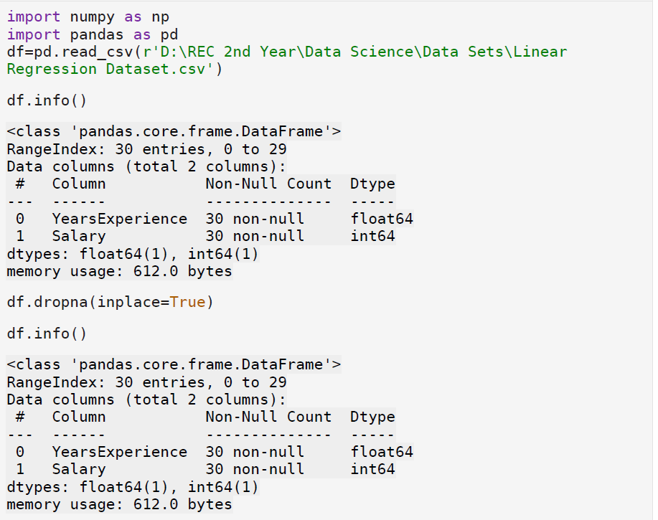

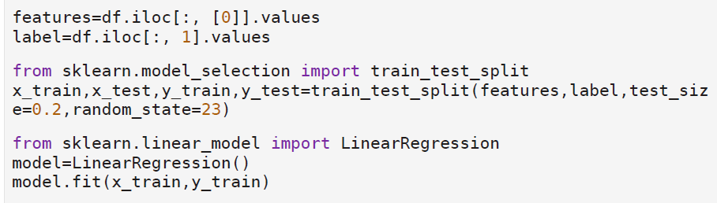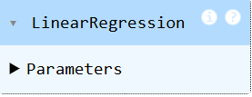

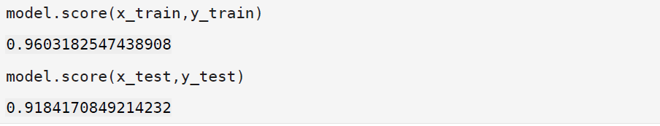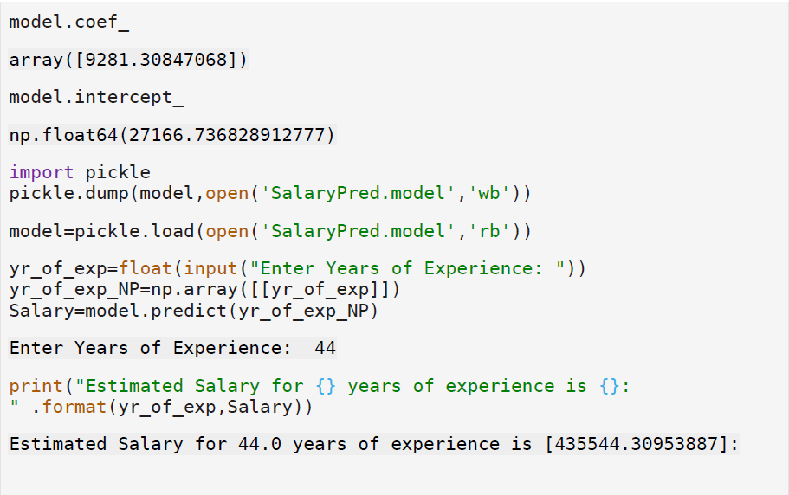

Result:
Thus evaluating Linear Regression for a dataset is completed using a python program.

